**EXP 2**  210701223

**Run a basic Word Count Map Reduce program to understand Map Reduce Paradigm.**

**Aim:**

To run a basic Word Count MapReduce program.

**Procedure:**

**Step 1: Create Data File:**

Create a file named "word_count_data.txt" and populate it with text data that you wish to analyse.

Login with your hadoop user.

# nano word_count.txt

Output: Type the below content in word_count.txt

# Step 2: Mapper Logic - mapper.py:

Create a file named "mapper.py" to implement the logic for the mapper. The mapper will read input data from STDIN, split lines into words, and output each word with its count.

nano mapper.py

# Copy and paste the mapper.py code

#!/usr/bin/env python3

# import sys because we need to read and write data to STDIN and STDOUT #!/usr/bin/python3

import sys

for line in sys.stdin:

line = line.strip() # remove leading and trailing whitespace words = line.split() # split the line into words

for word in words:

print( '%s\t%s' % (word, 1))

.

# Step 3: Reducer Logic - reducer.py:

Create a file named "reducer.py" to implement the logic for the reducer. The reducer will aggregate the occurrences of each word and generate the final output.

nano reducer.py

# Copy and paste the reducer.py code

# reducer.py

#!/usr/bin/python3

from operator import itemgetter import sys

current_word = None current_count = 0 word = None

for line in sys.stdin: line = line.strip()

word, count = line.split('\t', 1) try:

count = int(count) except ValueError:

continue

if current_word == word: current_count += count

else:

if current_word:

print( '%s\t%s' % (current_word, current_count)) current_count = count

current_word = word if current_word == word:

print( '%s\t%s' % (current_word, current_count))

# Step 4: Prepare Hadoop Environment:

Start the Hadoop daemons and create a directory in HDFS to store your data.

start-all.sh

hdfsdfs -mkdir /word_count_in_python

hdfsdfs -copyFromLocal /path/to/word_count.txt/word_count_in_python

# Step 6: Make Python Files Executable:

Give executable permissions to your mapper.py and reducer.py files.

chmod 777 mapper.py reducer.py

# Step 7: Run Word Count using Hadoop Streaming:

Download the latest hadoop-streaming jar file and place it in a location you can easily

access.

Then run the Word Count program using Hadoop Streaming.

hadoop jar /path/to/hadoop-streaming-3.3.6.jar \

-input /word_count_in_python/word_count_data.txt \

-output /word_count_in_python/new_output \

-mapper /path/to/mapper.py \

-reducer /path/to/reducer.py

# Step 8: Check Output:

Check the output of the Word Count program in the specified HDFS output directory

. hdfs dfs -cat /word_count_in_python/new_output/part-00000

**OUTPUT:**

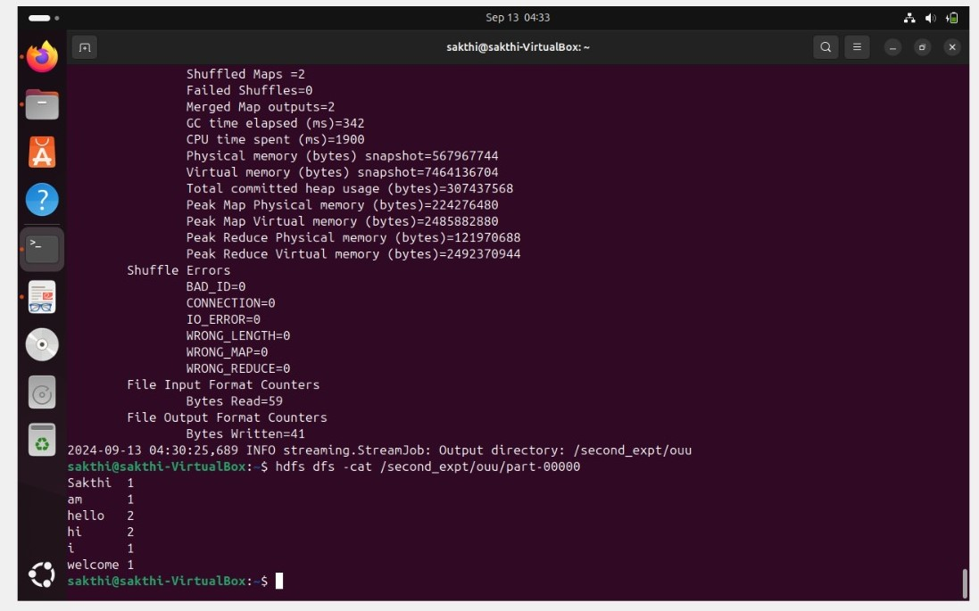

**Result:**

Thus, the program for basic Word Count Map Reduce has been executed successfully.